Capture and analyse the packets:

http://gaia.cs.umass.edu/wireshark-labs/HTTPwireshark-file1.html

* Is your browser running HTTP version 1.0 or 1.1? What version of HTTP is the server running?

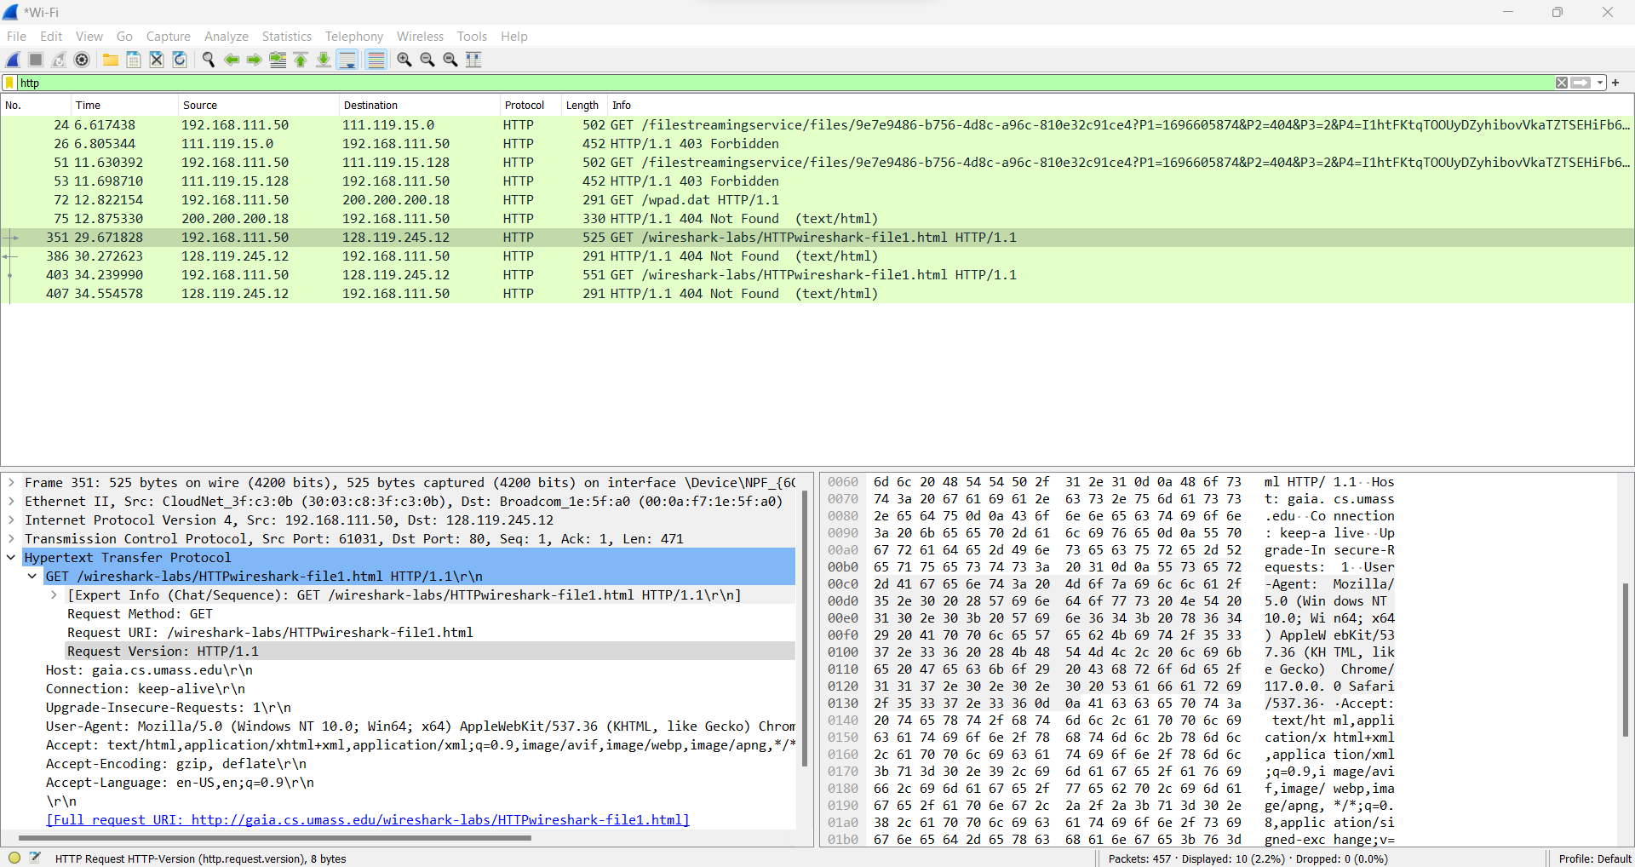

* What languages (if any) does your browser indicate that it can accept to the server?

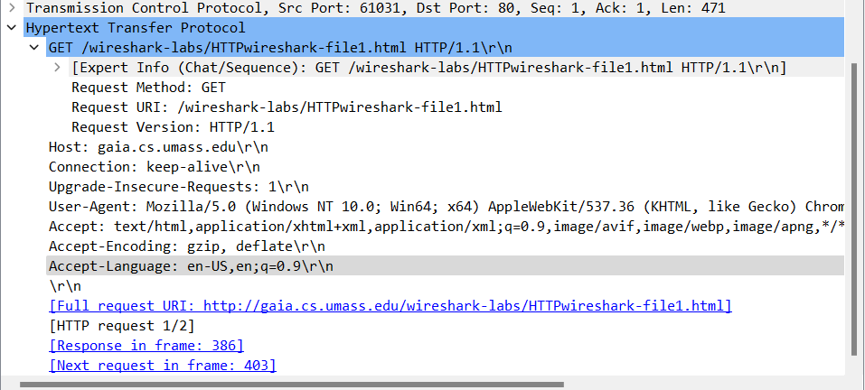

* What is the IP address of your computer? Of the gaia.cs.umass.edu server?

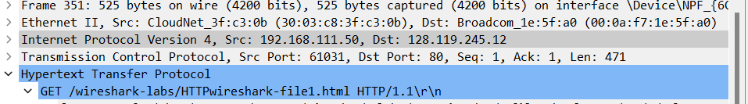

* What is the status code returned from the server to your browser?

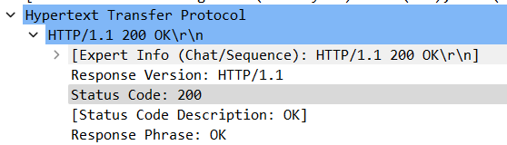

* When the HTML file that you are retrieving was last modified at the server?

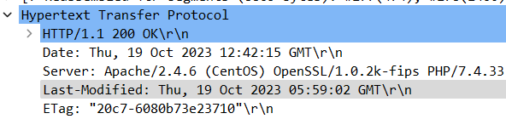

* How many bytes of content are being returned to your browser?

http://gaia.cs.umass.edu/wireshark-labs/ HTTPwireshark-file4.html

* Analyse the packet and check whether any image file is there? If so, save the file in your local folder and display it.
* Check any packet’s status is given as ‘Not Modified’. Why the packet is showing the above status.